Project Design Phase-II
Technology Stack (Architecture & Stack)

Date | 2 October 2026
Team ID | Team 7  Team Members: Haresh S (Team Leader), Gobika M, Hariharan M, Harini G
Project Name | Streamlining IT Procurement: Automating Standard Laptop Orders with Flow Designer
Maximum Marks | 4 Marks

Technical Architecture:
The Deliverable shall include the architectural diagram as below and the information as per the table1 & table 2
Automated standard laptop order processing using ServiceNow Flow Designer
Flow: User orders a Standard Laptop > Approver approves the request > Flow Designer runs "Standard laptop task" > Catalog Task created and assigned to the Hardware group for configuration.
Guidelines:
Include all the processes (As an application logic / Technology Block)
Provide infrastructural demarcation (Local / Cloud)
Indicate external interfaces (third party API’s etc.)
Indicate Data Storage components / services
Indicate interface to machine learning models (if applicable)
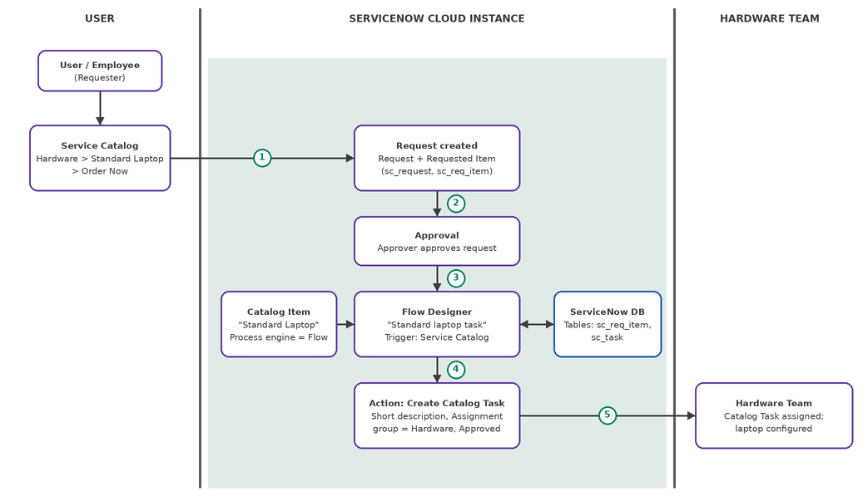

Table-1 : Components & Technologies:
S.No | Component | Description | Technology
 | User Interface | Employees order a Standard Laptop from the Service Catalog (Hardware > Standard Laptop > Order Now) and track the Request; approvers and the hardware team work through the ServiceNow web interface. | ServiceNow Service Catalog / Service Portal (platform-provided HTML, CSS, JavaScript)
 | Application Logic-1 | Flow Designer flow "Standard laptop task" (Application: Global, Run as: System user) starts through the Service Catalog trigger once the request is approved. | ServiceNow Flow Designer (Trigger: Service Catalog)
 | Application Logic-2 | Flow assignment: the flow is attached to the "Standard Laptop" catalog item (Maintain Items > Process engine) so every order runs the automation. | ServiceNow Maintain Items / Process Engine
 | Application Logic-3 | Create Catalog Task action: uses the Requested Item record to create a task with short description "Laptop need to Configured" and Assignment group "Hardware". | Flow Designer Action: Create Catalog Task (Assignment group = Hardware)
 | Database | Request, Requested Item, Approval and Catalog Task records with their field values (short description, description, assignment group, approval). | ServiceNow platform tables (sc_request, sc_req_item, sc_task)
 | Cloud Database | Database hosted and managed on the ServiceNow cloud instance; no separate database service is used. | ServiceNow cloud instance database
 | File Storage | No separate file storage required; any attachment on a request is kept in the platform attachment store. | ServiceNow Attachments (platform storage)
 | External API-1 | Not applicable: no external API is used; the entire process runs inside ServiceNow. | Not applicable
 | External API-2 | Not applicable: no second external API is used. | Not applicable
 | Machine Learning Model | Not applicable: no machine learning model is used; the process is rule-based automation. | Not applicable
 | Infrastructure (Server / Cloud) | Application deployment on Cloud (SaaS / PaaS)  Local Server Configuration: Not applicable (no local server)  Cloud Server Configuration: ServiceNow cloud instance accessed through a web browser | ServiceNow Cloud

Table-2: Application Characteristics:
S.No | Characteristics | Description | Technology
 | Open-Source Frameworks | No separate open-source framework is added; the solution is built on the ServiceNow low-code platform using Flow Designer. | ServiceNow Flow Designer (low-code)
 | Security Implementations | Access is controlled through user login and roles for requester, approver and hardware team; the flow runs as System user; the instance is accessed over HTTPS. | ServiceNow roles and ACLs, user authentication, HTTPS (TLS)
 | Scalable Architecture | The platform follows a multi-tier design (presentation, application, database); new orders run the same flow without code changes, so volume can grow. | ServiceNow multi-tier cloud platform, Flow Designer
 | Availability | The application is hosted on the managed ServiceNow cloud, which provides platform-level redundancy and failover. | ServiceNow managed cloud infrastructure
 | Performance | Catalog task creation is event-driven and automatic, removing manual steps and delays between approval and configuration. | Flow Designer event-driven execution

References:
https://c4model.com/
https://developer.ibm.com/patterns/online-order-processing-system-during-pandemic/
https://www.ibm.com/cloud/architecture
https://aws.amazon.com/architecture
https://medium.com/the-internal-startup/how-to-draw-useful-technical-architecture-diagrams-2d20c9fda90d

